Girls Trip to Michigan
Converge in Chicago on August 28/29
8/29--PU Rental car—load up and leave by 2 pm (preferable before) Rental fee $570 (Costco/Budget) This may change according to everyone’s arrival times to Chicago.
1--Grand Rapids (3 hrs 18)
2—Ludington (1 hr 45) *note for the future: this is the port for the Badger Ferry that takes you + car across Lake Michigan to Wisconsin)
Climb Lighthouse, Pine Village, Port Museum, kayak lake Sleep here? Depending on departure time from Chicago
8/30
3—Sleeping Bear Dunes (2 hrs) NEED PASS per car $25 https://www.recreation.gov/sitepass/74294
For less than 3 hour visit:
-Take a drive on the 7-mile Pierce Stocking Scenic Drive
-Trek up the Dune Climb - or sit back and watch the rest of your party climb
-Explore Glen Haven and the Maritime Museum
-Dip your toes in the tranquil Loon Lake
4—Traverse City (38 mins) sleep here?
-Wineries, distilleries, city trail, tour town, lighthouse, eat well
8/31
5—Torch Lake (40 mins)
-Take a drive around the lake…Tour Town of Alden?
-Clear-bottom kayaks or do a boat ride down the lake
-Petosky stone search
Bryant Park Beach--1097 Peninsula Dr, Traverse City, MI 49686
Van’s Beach--205 Cedar St, Leland, MI 49654
Peterson Park--10001 E Peterson Park Rd, Northport, MI 49670
Magnus Park--901 West Lake St, Petoskey, MI 49770
Cross Village Beach--100 Park Ln, Harbor Springs, MI 49740

6—Charlevoix (23 mins)
-Lock, Castle Farms, shop the town, lighthouse
7—Mackinac City (1 hr 10) This is just a place to base ourselves to go to Mackinaw Island Sleep here 2 nights?
9/1-2
Mackinaw Island—7:00 AM Park at the Ferry dock -OR call shuttle and it will pick us up if we are staying within a 1.5 mile radius of the ferry dock. If driving to ferry, arrive ½ hr prior to departure (7:30 AM).
Ferry info 1800.638.9892, $10 parking, $52 per person round trip
Ride bikes, tour town, eat well, return at 4/4:30 PM?
9/3
8—Frankenmuth (2 hrs 50)
-Little Bavaria, cute, quaint, good food?
9—Midland, Saginaw, Howell (1 hr-1 hr 30)
CANADA DRIVE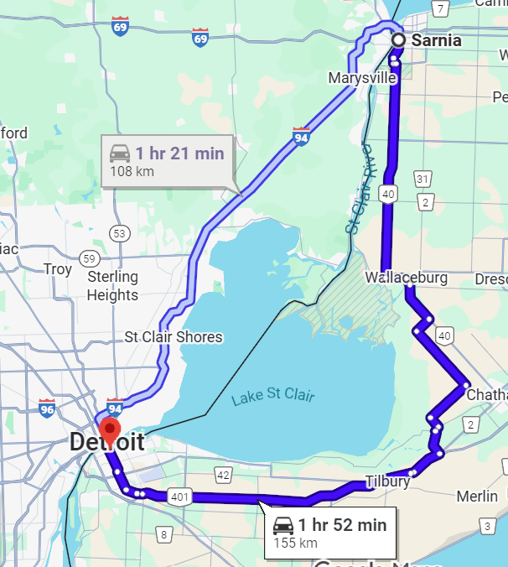
Small livable towns (Howell, “best overall downtown”!)
10*—Sarnia CANADA (2 hrs to border) Sleep here?
9/4
11*—Windsor CANADA (2 hrs to border)
12*—Detroit (meet Julia downtown?) Sleep Julia’s
9/5
13—Ann Arbor?
14—Kalamazoo (1 hr 46)
To take a driving break?
15—Home (3 hrs)
I COULDN’T GET ANY MORE STOPS ON THE MAP, AND IT WOULD NOT SHOW INSIDE CANADA
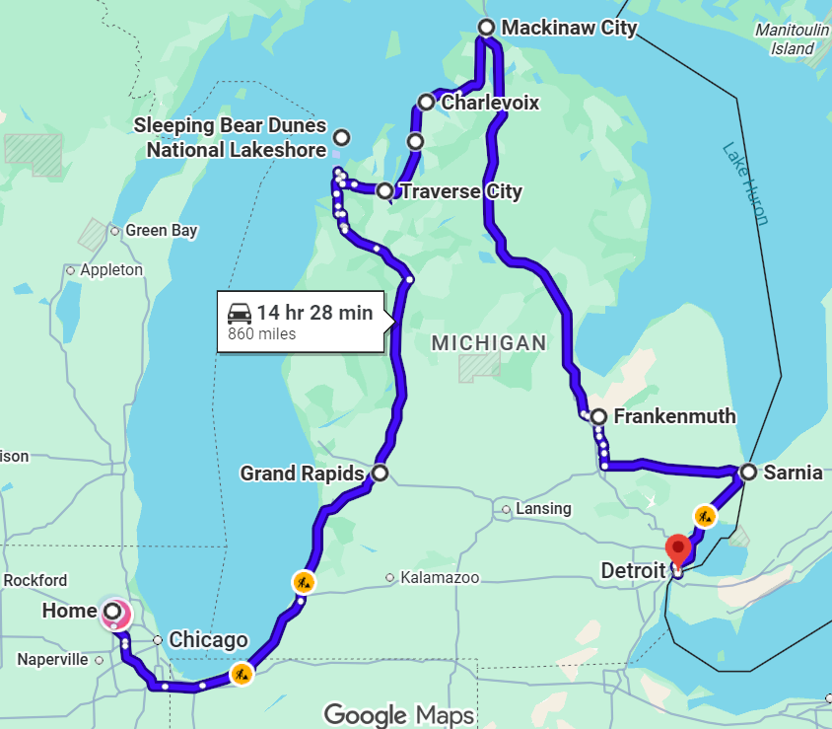

NOTABLES>>>

RENTAL CAR: Canada: Vehicles may be driven into Canada with no restrictions. The rental counter must be notified at the time of the rental that you plan to drive into Canada so the location can provide a copy of the "Canadian Non-Resident Insurance Card" or you may download the card www.avis.ca/content/dam/avis/na/ca/common/pdf-files/abg__canada_non_resident_card.pdf (provided at no cost). Based on availability, one-way rentals may be allowed to some Canada cities.
One additional driver fee will be waived for Costco members at participating locations. Age restrictions and renter requirements may apply.
Budget Confirmation Number: 38128110US6 Booked for pick-up on August 28, return September 7
COSTS—ESTIMATED, I HAVE NOT LOOKED THIS UP YET (divided by 3) I certainly hope it’s less than this….
Hotels/Bnbs $200-250/night (3 beds) 8 nights--$1600/3=$540 ea
Meals $65/day per person $520 ea
Gas $240/3=$80 ea
Car rental $570/3=$190 ea
Ferry, parking, entry fees $100/3=$35 ea
Various activities? Kayak rental, boat tours, misc.

APPROX $1300 each not including airfare

